Annotated Lesson Plan Year 3 Geography
Recorded/live online lesson
Lesson: Geography |  | Year Group: 3
LQ: What is a settlement?
By the end of this lesson you will know what a settlement is and some examples of different types of settlements. (Villages, Towns and Cities)
Follow high quality curriculum sequence from school curriculum plan.

Tech is using platforms which have been rehearsed in school and Class Dojo links. Overcommunication for parents. May be better recorded rather than LIVE to allow parents to watch on a tablet or phone WITH pupils when they are able (around work or sibling commitments) In addition Y3 would need a recording to re-watch as retrieval or overlearning.
Make power point to present on live lesson.
- Include pictures and timings for each activity on the slide; limit cognitive load of information on slides – reduce words and make sure images are relevant.
- Ensure common errors misconceptions and opportunities for questioning are included in the notes section under each slide.

Slide 1  (Visible as children join lesson) | What you will need for this lesson (everything is in your tray)  - Your whiteboard and whiteboard pen  - Geography booklet  - Geography writing book  - Pencil  Ensures readiness for the lesson, saves interruption later.  Include a picture prompt of each  Children to be sent home on remote learning lockdown with their learning trays from class which have the books and equipment in.  Children to be reminded in class how to access Class Dojo and Purple Mash as they have done since March and also as they are currently doing for uploading homework.  In a live lesson, when it is time to start get them to show you they are ready with a quick paced, friendly countdown, eg “Show me your booklet in 3… 2… I can see we’re all nearly there and…1! Lovely – that’s everyone ready for the lesson, well done! |  | 2 mins
Slide 2 | If live: introduce and set expectations to children.  - Cameras on  - Muted mics  - Be ready to answer questions if I call on you  - Be present and interact  - Sitting still (phones with cameras on leaning against something still)  Brief link to in school behaviour rewards and sanctions |  | 2 mins
Slide 3 | Do Now  Children to recap with quiz questions about previous learning (booklet page 9) Record in book.  Countdown – ask to show green pens when it is time to self-check their work  Engagement check – verbally question some children to gather, check that all children are visible. Ask for children to hold up book to camera – show they’ve answered and corrected with green pen  Could ask for answers to multiple choice questions to be shown on whiteboard or type choice A,B,C,D into chat function. Give them a countdown to press return so they all do it at once – chance to spot misconceptions and explore. |  | 5 mins
Slide 4 | Learning Question and key vocabulary on slide with pictures (dual coding)  Vocab: settlement, villages, towns, cities  Research link to Dual Coding Oliver Caviglioli; Vocabulary Tier 3 introduction here.
Slide 5 | Definition of a settlement (booklet page 10)  Take this opportunity to ensure children understand the word Settlement and can name familiar settlements (EG Bedford, Elstow). |  | 5 mins
Slide 6 | Pictures of a village and information (key points, not too much writing)
Slide 7 | Pictures of a town and information (key points, not too much writing)
Slide 8 | Pictures of a city and information (key points, not too much writing)
Slide 9 | QUIZ/Recap Point – what is a settlement? Give 3 options and children to hold up on their whiteboards the correct number/letter that shows the answer.  Take a screenshot and tell children you are doing this so they act as if in a “show me” moment in class. Note children with incorrect answers or not engaging.  Teach Like A Champion strategies in place including Cold Call, No Opt Out – model by teacher and pupils repeating. Call and Response works well. Training in Warm Strict is also essential here.  Delete screenshot once you have checked the whiteboards. |  | 2 mins
Slide 10 | Have one statement from booklet (page 12) with pictures visible.  Read out the statement. Scaffold for children; break down questions as needed  Set expectations that the children will write on their whiteboards V T or C to show Village, Town or City on “show me”.  Count 1, 2, 3 and show me  Children hold up the correct answer.  Screen shot the screen to assess or write on feedback sheet to assess.  Repeat for a few more examples. |  | 8 mins
Slide 11 | QUIZ/Recap Point – what is a settlement? Match up V C T with a definition. |  | 2 mins
Slide 12 | Independent Task:  Question 5 page 12 of booklet.  Why is a town different to a village? Why is a city different to a town?  Children to go away and record their sentences and then upload photo for teacher.  Elstow School has been doing this throughout Lockdown. All our children have access to Class Dojo and we have been asking parents to take a picture and upload. We continue this now for homework for all year groups weekly.  Our success with high levels of pupil engagement (91%) has been enhanced by the fact that prior to the school closure, Elstow rehearsed with every class, how to find their class dojo login, how to access the class story and how to find their work. We also posted it on the front of the website – and continue to do so, so all parents can track what we are doing. Pupils have had “Zoom” rehearsal lessons in school, whereby the teacher has taught them a lesson through laptops whilst in school (teacher in room with pupils) so they could ask questions and practice before being asked to learn online at home and without support. Some pupils have also had Zoom lessons with teachers that are self-isolating whilst the pupils were in school, and have had reading sessions with learning support staff isolating at home via Zoom, which has also helped to familiarise them with the process and how it will work from home. |  | Offline task to complete and upload by the end of the day
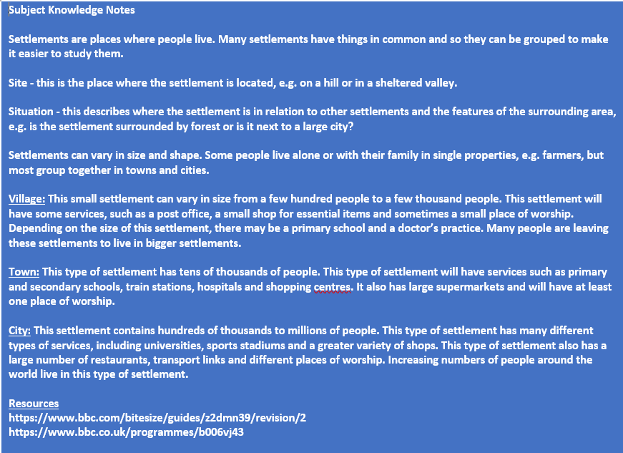
Sequencing should follow the curriculum sequence as per the medium term plan which is published in school.
Catering for non digital access – would be through the booklets and delivering to houses (as done during lockdown) to ensure pupils have the resources. Inevitably, these pupils will have a more fragile learning experience and this will need to be taken into account on return to school. To mitigate against this, booklets are highly scaffolded with learning chunked to provide a structure to learning. Teacher contact with these pupils is a priority to answer questions and keep pupils on track with their work.

